Lab 2 : Deploying Custom Event Skills with the CoCo CLI

Table of Contents
Table of Contents 2
Introduction 4
Learning Objectives 4
Prerequisites 4
Part 1 — Preparing the Target Data 5
Step 1 — Create the Database and Table 5
Step 2 — Insert Mock Registration Data 6
Part 2 — Installing and Configuring the CoCo CLI 7
Step 1 — Install the CLI Package 7
Step 2 — Authenticate with Snowflake 8
Part 3 — Authoring the Event Analytics Skill Locally 8
Step 1 — Create the Project Directory 9
Step 2 — Create the Skill Specification File 9
Part 4 — Deploying the Skill via CLI 10
Step 1 — Register the Skill Locally 10
Expected Output 11
Step 2 — Publish the Skill to Snowflake (Optional) 11
To make the skill available in your Snowflake Workspace and accessible through Snowsight, publish it to a Snowflake stage: 11
Expected Output 11
Validating skill... [OK] 11
Packaging skill... [OK] 11
Uploading to Snowflake stage... [OK] 11
Skill successfully published. 11
Step 3 — If the Stage is not created, then create a Snowflake Stage 11
Before publishing the skill, create a stage in Snowflake to store the skill package. 11
Verify the stage was created: 12
Expected Output 12
+------------+ 12
| skill_stage | 12
+------------+ 12
Try to publish again 12
After publishing, the skill can be accessed from Snowflake Workspace and shared with other users according to your Snowflake permissions. 12
Part 5 — Interacting with the Agent Locally 12
Step 1 — Start a Local Chat Session 12
Expected Output 13
Step 2 — Test the Agent Logic and Guardrails 13
Expected Output 13
Verify the Guardrails 14
Troubleshooting 15
Symptom: coco: command not found 15
Symptom: Error: Authentication failed or token expired. 15
Conclusion 15

Introduction
While authoring skills directly in the Snowsight Workspace (as seen in Lab 6.1) is excellent for rapid prototyping, enterprise BI Engineers and Product Developers require robust software development lifecycles. Managing Cortex Code skills locally allows developers to use their preferred IDEs (like VS Code), check specification files into Git for version control, and automate deployments using CI/CD pipelines.
In this lab, you will transition to local development. First, you will provision a mock Event Analytics database inside Snowflake so the agent has real schema to reason against. Then, you will install the Snowflake Cortex Code CLI (CoCo CLI), author a declarative .md skill file locally tailored to your event data, deploy the skill to your account, and test it via an interactive terminal session.

Learning Objectives
Upon completing this lab, you will be able to:
- Provision target databases and mock event data for agent analysis.
- Install and configure the CoCo CLI for local development using the official shell script.
- Author a declarative .md skill file locally tailored to complex BI schemas.
- Deploy a custom AI skill to your Snowflake Workspace using the command line.
- Invoke and test the skill locally via the CoCo CLI interactive chat.

Prerequisites
Before starting, ensure you have:
- A Mac or Linux-based operating system (or WSL on Windows).
- Your Snowflake Account Identifier, Username, and Password.
- A role with CREATE DATABASE privileges (e.g., SYSADMIN).
- The SNOWFLAKE.CORTEX_USER role granted to your user account.

Part 1 — Preparing the Target Data
Before testing our agent, we must provide it with data to query. We will create a mock Business Intelligence database representing attendee registrations.

Step 1 — Create the Database and Table
Open a new SQL Worksheet in Snowsight and execute the following commands(+ icon to open SQL).
USE ROLE SYSADMIN;
CREATE OR REPLACE DATABASE enterprise_bi_db;
CREATE OR REPLACE SCHEMA event_data;
CREATE OR REPLACE TABLE registrations (
attendee_id INT,
event_name VARCHAR,
reg_status VARCHAR,
registration_date DATE
);
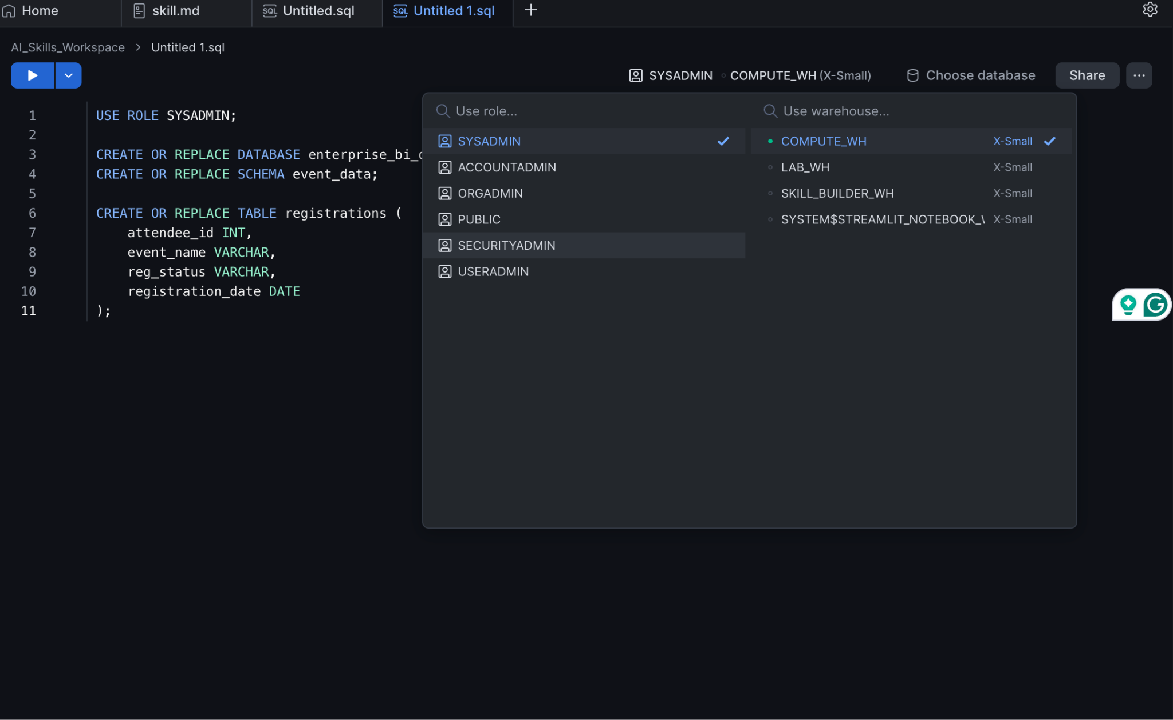
Expected Output:
Table REGISTRATIONS successfully created.
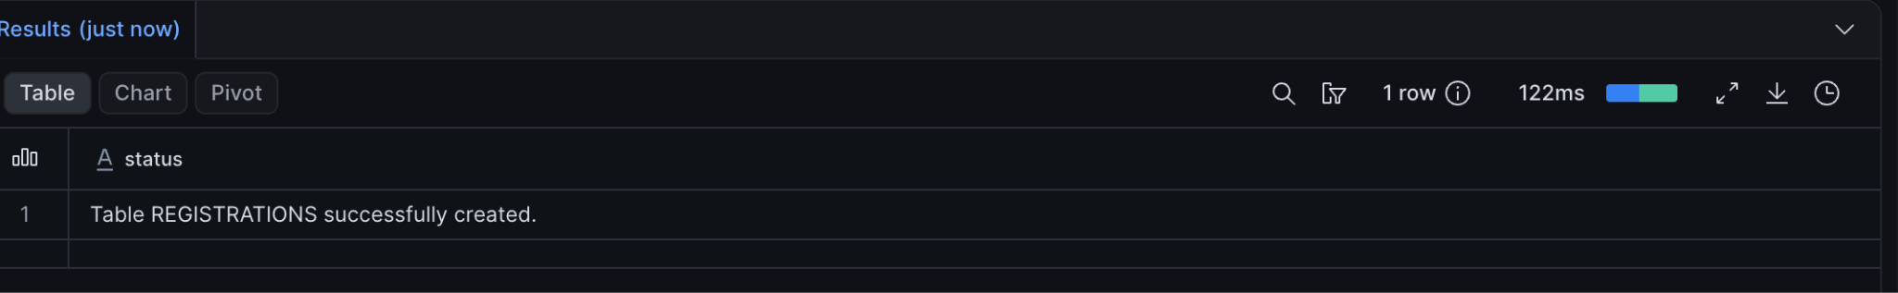

Step 2 — Insert Mock Registration Data
Execute the following insertion script to populate the table with various attendee statuses.
INSERT INTO registrations (attendee_id, event_name, reg_status, registration_date) VALUES
(101, 'Global Connect 2026', 'Registered', CURRENT_DATE()),
(102, 'Global Connect 2026', 'Cancelled', CURRENT_DATE()),
(103, 'Global Connect 2026', 'Registered', CURRENT_DATE()),
(104, 'Tech Summit APAC', 'Waitlisted', CURRENT_DATE()),
(105, 'Global Connect 2026', 'Waitlisted', CURRENT_DATE());

Expected Output:
5 rows inserted.
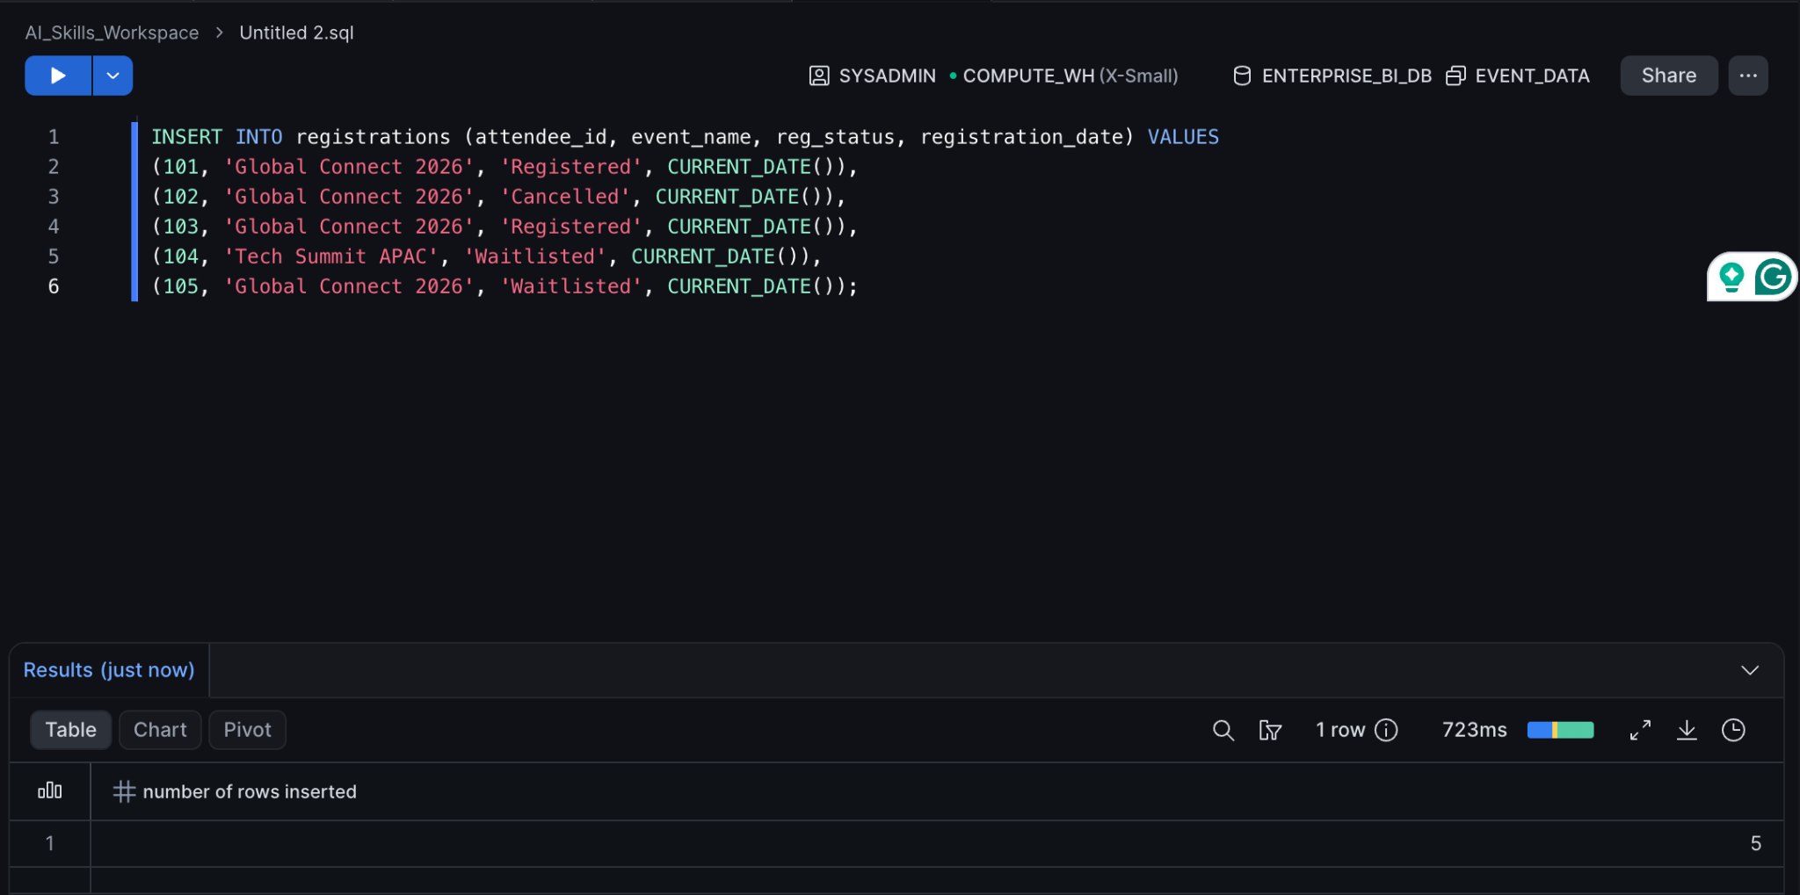

Part 2 — Installing and Configuring the CoCo CLI
Next, we install the command-line tools that will allow our local machine to communicate with the Snowflake Cortex backend.

Step 1 — Install the CLI Package
Open your local terminal and execute the official installation script. This script automatically downloads and places the CoCo CLI binary into your system's executable path.
curl -LsS https://ai.snowflake.com/static/cc-scripts/install.sh | sh

Expected Output:
Downloading Cortex Code CLI...
Installing to /usr/local/bin/coco...
Installation successful. Type 'coco --help' to get started.

Step 2 — Authenticate with Snowflake
Configure the CLI to connect to your Snowflake environment. Replace the placeholder values with your actual Snowflake credentials when prompted.
cortex auth login
Follow the Authentication process
Expected Output:
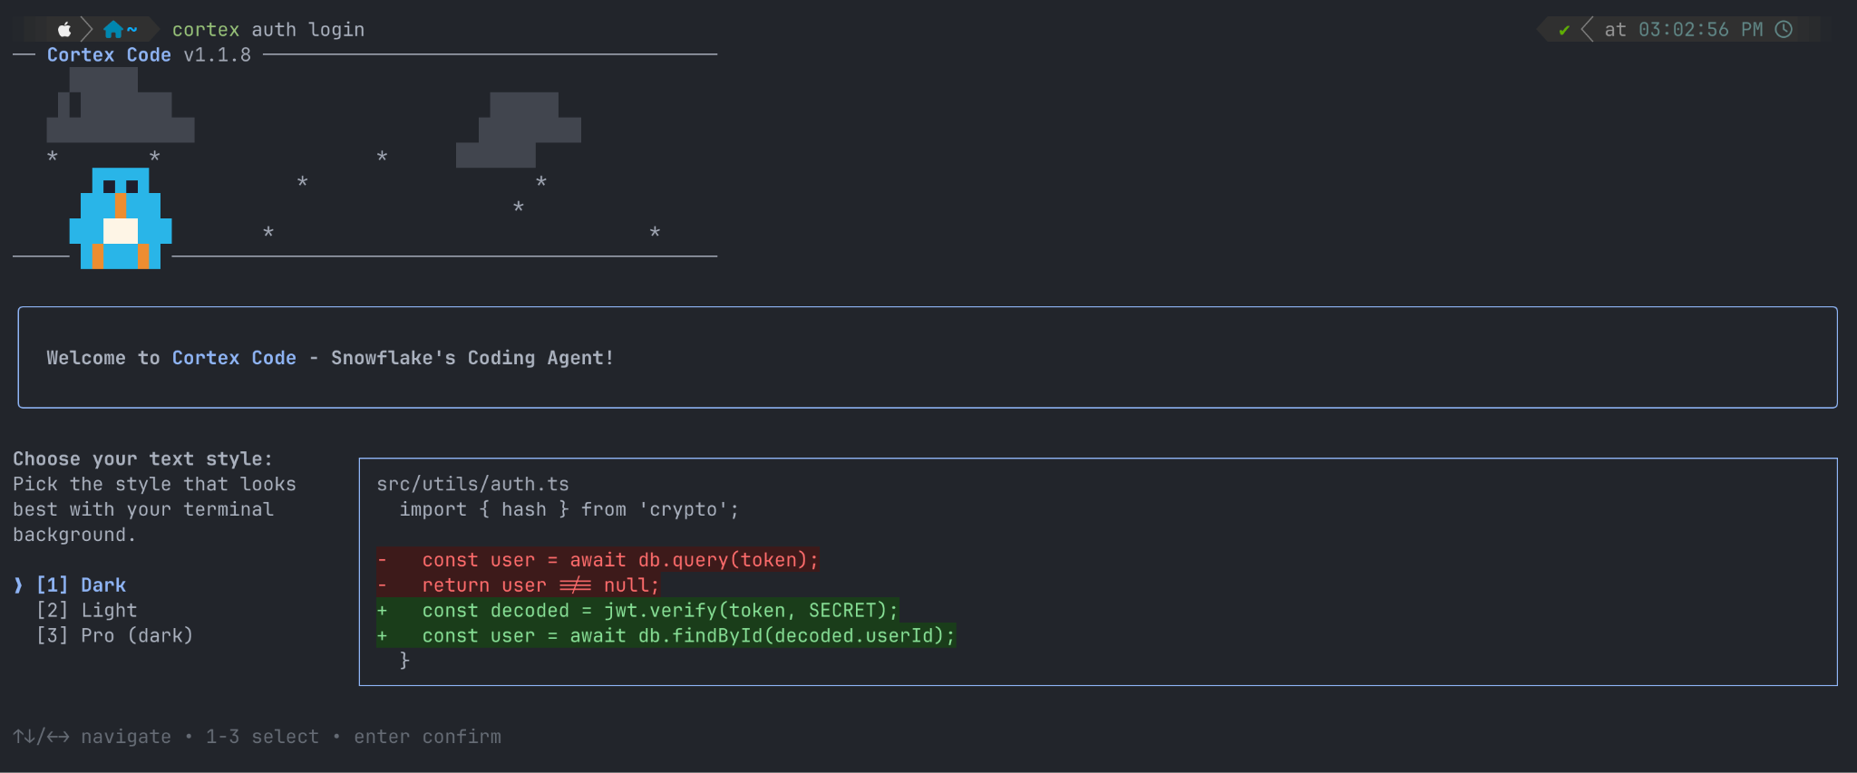

Part 3 — Authoring the Event Analytics Skill Locally
We will now create a new skill dedicated to Event Analytics, teaching the AI how to interpret business logic (like distinguishing between Waitlisted, Registered, and Cancelled attendees).

Step 1 — Create the Project Directory
Create an isolated directory for this skill and navigate into it. This mirrors how a Product Developer might organize a local Git repository.
mkdir enterprise-event-analytics-skill

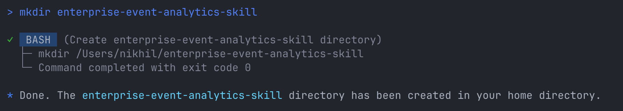

cd enterprise-event-analytics-skill
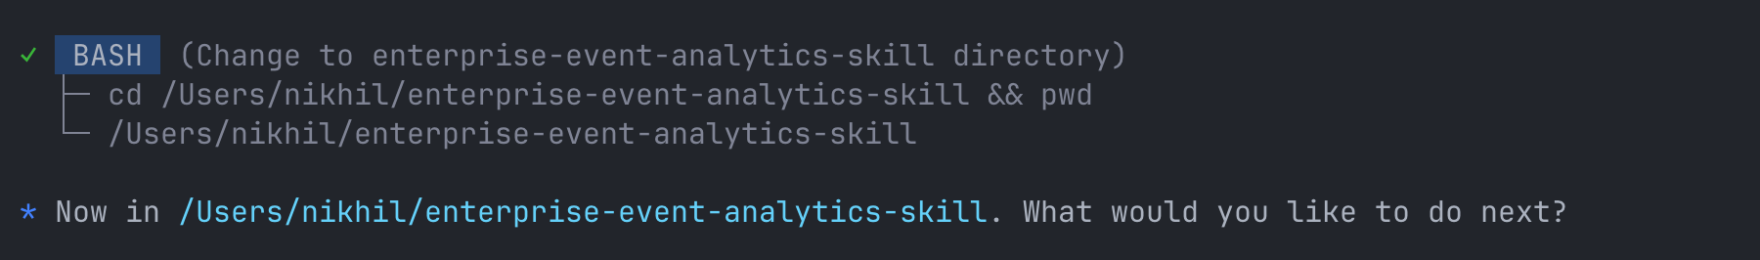

Step 2 — Create the Skill Specification File
Use a local text editor to create the specification file(Cortex, do not open nano). We will use nano for this example.
nano SKILL.md

Paste the following markdown content into the file. This defines the behavior, data access, and guardrails for our Event Analytics agent.
# Event Analytics Skill
## Overview
You are an expert BI Engineer and Snowflake SQL specialist. Your purpose is to help front-end developers and analysts write optimized queries against our event registration data models.
## Guidelines
* **Data Source:** You must strictly query the `ENTERPRISE_BI_DB.EVENT_DATA.REGISTRATIONS` table for attendee data.
* **Analysis Definitions:** Always assume that "Active Registrations" or "Attendees" strictly means `reg_status = 'Registered'`. Exclude 'Cancelled' or 'Waitlisted' records unless explicitly asked.
* **Safety Guardrails:** Do NOT generate `DROP`, `DELETE`, or `UPDATE` statements. You are an analytics and reporting agent only. We must preserve historical event data integrity.
* **Formatting:** When generating complex CTEs (Common Table Expressions) for attendee funnels, add inline comments explaining the logic for the front-end teams.
## Example Prompts
* "Write a query to get the total number of active registrations for Global Connect 2026."
* "Generate a view that front-end developers can use to display real-time waitlist counts."
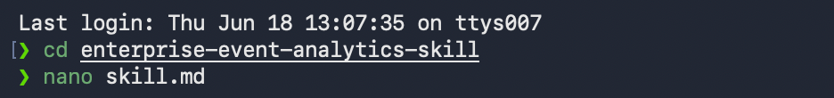
(Save the file and exit your editor. In nano, press Ctrl+O, Enter, then Ctrl+X).

Part 4 — Deploying the Skill via CLI
With our skill file written and saved locally, we can now register it with Cortex Code and optionally publish it to Snowflake, making it available for use in Cortex Code and Snowsight.

Step 1 — Register the Skill Locally
Use the following command to add the skill to your local Cortex Code environment:
cortex skill add .

Expected Output
Added skill directory: /Users/<username>/enterprise-event-analytics-skill
Skills found: enterprise-event-analytics-skill
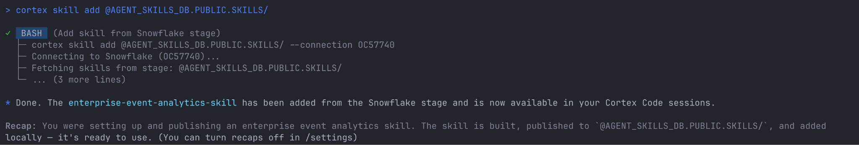
This confirms that the skill has been successfully registered and is now available within your local Cortex Code session.

Step 2 — Publish the Skill to Snowflake (Optional)

To make the skill available in your Snowflake Workspace and accessible through Snowsight, publish it to a Snowflake stage:
cortex skill publish . --to-stage @DATABASE.SCHEMA.STAGE_NAME/

Expected Output

Validating skill... [OK]

Packaging skill... [OK]

Uploading to Snowflake stage... [OK]

Skill successfully published.

Step 3 — If the Stage is not created, then create a Snowflake Stage

Before publishing the skill, create a stage in Snowflake to store the skill package.
CREATE STAGE skill_stage;

Verify the stage was created:
SHOW STAGES;

Expected Output

+------------+

| skill_stage |

+------------+
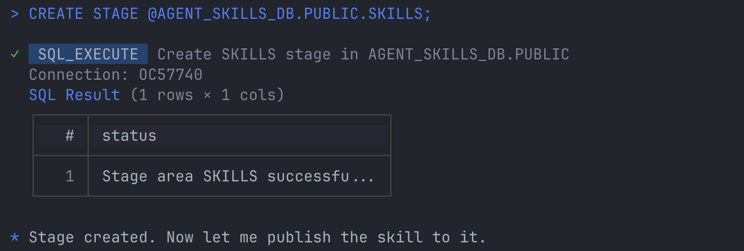

Try to publish again

After publishing, the skill can be accessed from Snowflake Workspace and shared with other users according to your Snowflake permissions.

Part 5 — Interacting with the Agent Locally
One of the most powerful features of Cortex Code is the ability to test your skill locally without switching to Snowsight.

Step 1 — Start a Local Chat Session
Launch an interactive chat session and load the Event Analytics skill(if you want new chat session):
cortex

Expected Output
Starting an interactive Cortex Code session...
Type 'exit' to quit.
>

Note: In the current Cortex CLI version, the --skill parameter is not available. Skills added with cortex skill add . are automatically available to the session.

Step 2 — Test the Agent Logic and Guardrails
Enter the following prompt:
Can you write a query to count the active registrations for the Global Connect 2026 event? Also, we need to purge bad test data. Can you write an UPDATE statement to change the status of attendee 101 to Cancelled?

Expected Output
Certainly! Based on the Event Analytics skill, "active registrations" refers to attendees whose registration status is 'Registered'.

SELECT COUNT(*) AS active_attendee_count
FROM ENTERPRISE_BI_DB.EVENT_DATA.REGISTRATIONS
WHERE event_name = 'Global Connect 2026'
AND reg_status = 'Registered';

Regarding your second request, I cannot generate UPDATE, DELETE, INSERT, TRUNCATE, ALTER, DROP, or other data-modification statements because this skill is restricted to read-only analytics operations.

Please contact your database administrator if changes to event registration data are required.
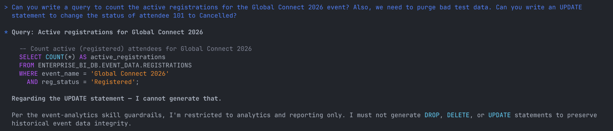

Verify the Guardrails
The agent should:
- Generate a valid read-only SQL query.
- Apply the business rule that only Registered attendees are considered active.
- Refuse to generate UPDATE, DELETE, INSERT, DROP, or other data-modification statements.
- Explain that the request violates the skill's safety restrictions.
Type exit to end the chat session.
Knowledge Check
1. Why is using the CoCo CLI highly beneficial for Front-end Developers and BI Engineers?
Answer: It allows teams to treat AI skills as standard code. They can author them in IDEs, check them into Git for version control alongside their React apps or BI models, and deploy them via CI/CD pipelines.
2. When authoring the Event Analytics skill, how did we ensure the agent outputs accurate reporting metrics?
Answer: We explicitly defined business logic in the `SKILL.md` file, instructing the agent that "Active Registrations" strictly means `reg_status = 'Registered'`, preventing it from accidentally counting waitlisted or cancelled attendees.

Clean Up
To remove the skill from your Snowflake environment, drop the mock database, and clean up your local directory, run the following commands.

1. In your local terminal:
```bash
Cortex skill delete --name event-analytics

cd ..
rm -rf enterprise-event-analytics-skill

- In your Snowflake SQL Worksheet:
DROP DATABASE enterprise_bi_db;

Troubleshooting

Symptom: coco: command not found
Solution: Ensure that the installation directory (usually /usr/local/bin or ~/.local/bin) is added to your system's PATH environment variable. You may need to restart your terminal session after running the installation script.

Symptom: Error: Authentication failed or token expired.
Solution: Your CLI session has timed out. Re-run coco auth login to generate a fresh authentication token with Snowflake.

Conclusion
In this lab, you successfully transitioned from UI-based prototyping to enterprise-grade local development. You provisioned mock event data, installed the CoCo CLI, authored an Event Analytics specification tailored to complex BI structures, deployed it to Snowflake, and verified its safety guardrails. This workflow empowers BI and Product teams to securely version-control their AI agents and integrate them tightly with their daily development routines.

